Suppose that you were trying to use the approach in the textbook for transforming an NFA into a regular expression using the “eliminate state k” method. Which of the following “new” transitions would you need to compute if you want to eliminate state 3 in the NFA shown below (select all that apply): **new(1,1), new(1,2), new(1,f), new(2,2), new(2,1), new(2,f)**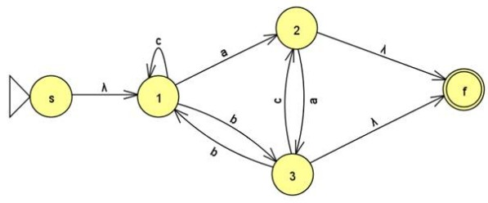

Suppose we wanted to create a Mealy Machine over the alphabet {a,b} that did the following:

- When it sees the 1st letter, it prints a star

- When it sees the 2nd letter, it prints whatever the 1st letter was

- When it sees the 3rd letter, it prints whatever the 2nd letter was

- When it sees the 4th letter, it prints whatever the 3rd letter was

- and so on…

Let’s call this the “almost repeat” machine.

Here’s a bunch of tests that I ran on my version of the “almost repeat” machine so you can get the idea (see left below):

Figure 1 shows a picture of the machine, except the labels were changed to be x’s and y’s:

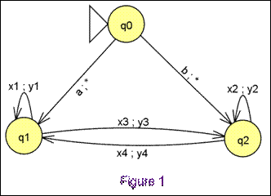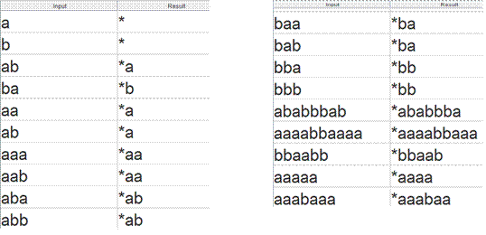

What label would you need to give to x1? **a**

What label would you need to give to y1? **a**

What label would you need to give to x2? **b**

What label would you need to give to y2? **b**

What label would you need to give to x3? **b**

What label would you need to give to y3? **a**

What label would you need to give to x4? **a**

What label would you need to give to y4? **b**

Suppose we wanted to create a Moore Machine over the alphabet {a,b} that did the following:

- Prints an X every time it sees the substring aba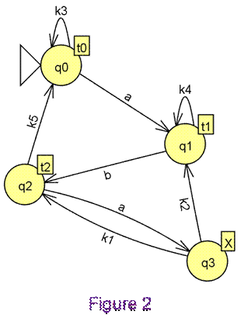

- otherwise, it just prints a *

Let’s call this the “aba detector” machine.

Here’s a bunch of tests that I ran on my version of the "aba detector” machine so you can get the idea (left below):

Figure 2 (right) shows a picture of my machine, except I changed the labels on some of the transitions to be k’s and some of the outputs to be t’s

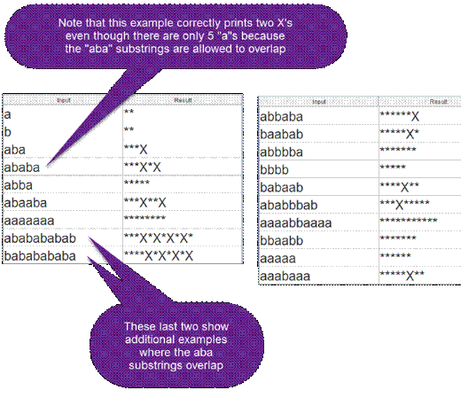

What label would you need to give to t0? **\***

What label would you need to give to t1? **\***

What label would you need to give to t2? **\***

What label would you need to give to k1? **b**

What label would you need to give to k2? **a**

What label would you need to give to k3? **b**

What label would you need to give to k4? **a**

What label would you need to give to k5? **b**